|  |
| --- |
| NC Workforce Development Boards Directors  Youth NextGen Forum Facilitator |
| Request for Proposal |

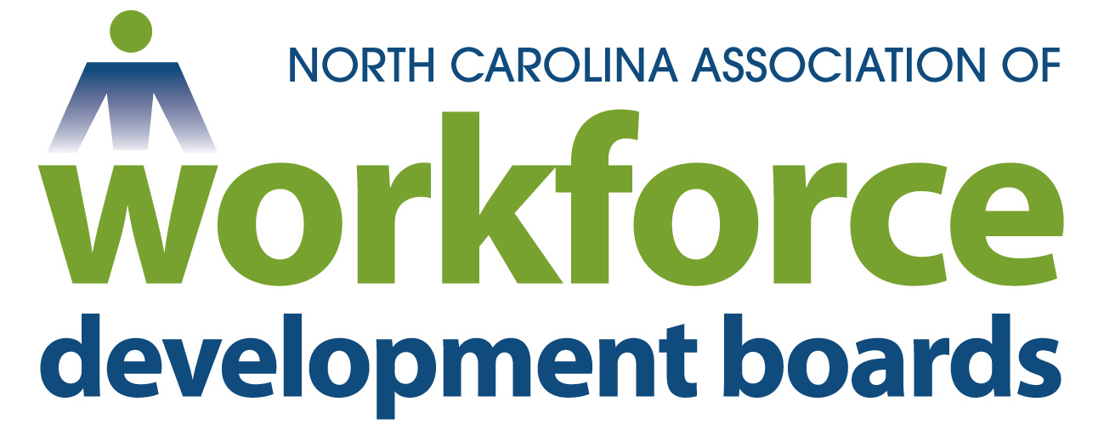**REQUEST FOR PROPOSALS**

10/11/2024

***North Carolina Workforce Development Boards***

***Youth NextGen Forum Facilitator***

**INTRODUCTION**

The North Carolina Association of Workforce Development Boards (NCAWDB) is the voice for workforce development in North Carolina. Comprised of 20 workforce boards with over 500 members, the Association is dedicated to enhancing North Carolina’s workforce by supporting local workforce development boards statewide.  The NCAWDB Executive Director’s Council (EDC) is comprised of the 20 Workforce Development Board Executive Directors and the Executive Director of NCAWDB.

Workforce Development Boards are the conveners of the workforce system on a local level in the state of North Carolina. Workforce Development Boards provide oversight, planning, and administration of the NCWorks Career Centers.

They are business-led and supported by local elected officials. The Boards are charged with bringing together industry, education, labor, community, government, and other stakeholders in the workforce to develop demand-driven strategies connected to regional economies and labor markets. They oversee local NCWorks Career Centers in partnership with the [NCWorks Commission](https://www.nccommerce.com/about-us/boards-commissions/ncworks-commission) and the [Division of Workforce Solutions](https://www.nccommerce.com/about-us/divisions-programs/workforce-solutions-division) to deliver workforce solutions, assist job seekers with improving their skills and finding jobs, and help businesses develop a qualified workforce.

As part of the NCAWDB, The Executive Directors Council (EDC) is a unified voice for the NC workforce development system and an instrumental partner in developing North Carolina’s economic future.

**PURPOSE/SCOPE OF WORK**

The purpose of this Request for Proposal (RFP) is to solicit proposals from a qualified facilitator to deliver the service of moderating and presenting at the Annual Youth NextGen Forum. We are seeking an experienced and dynamic facilitator to lead a Youth Forum training session aimed at youth program leads across the state. This interactive forum will focus on providing practical training in recruitment, engagement, and retention strategies tailored for youth workforce programs. The selected facilitator will:

Design and deliver an engaging session that covers innovative approaches to attracting and retaining youth participants.

Lead discussions and activities that allow participants to exchange best practices and insights.

Foster a collaborative environment where youth leads can enhance their skills in effectively managing their programs.

Provide actionable takeaways that attendees can implement in their respective programs.

The goal of the Executive Director’s Council is to have this service delivered in person to youth service professionals February 11th and 12th, 2025 at the Embassy Suites Hotel located at 204 Centreport Drive Greensboro, NC 27409.

The Director’s Council Youth NextGen Committee has identified the following areas of focus for the Youth NextGen Forum Facilitator:

Pre-Forum Preparation

* *Collaborate with organizing team/committee to develop agenda and forum materials.*
* *Develop ground rules and forum structure.*

During the Forum

* *Lead discussions and ensure all voices are heard.*
* *Develop and prepare several sessions that address Career Planning and the Youth Advisor role. Sessions should include several group activities and table topic discussions.*
* *Utilize innovation facilitation techniques to encourage attendee participation and engagement.*
* *Manage time effectively to ensure all topics are covered.*
* *Employ conflict management and resolution skills to keep the forum on track and moving forward.*

Post-Forum Preparation

* *Summarize key points and outcomes.*
* *Provide feedback to participants.*
* *Collaborate on post-forum evaluations and reports.*

**MINIMUM REQUIREMENTS:**

* Strong background in youth engagement and development
* Proven experience in facilitating forums, workshops or similar events
* Excellent communication and conflict management skills
* Familiarity with the targeted audience, demographics and local youth services
* Ability to create an inclusive and open environment

**Executive DIRECTORS COUNCIL RESPONSIBILITIES:**

The Executive Directors Council will provide the space, lunch, and reasonable A/V or other supplies needed for presentation, as available and agreed upon in advance.

**LOGISTICS:**

The training will be over 1½ day session, February 11th and 12th, 2025 in-person located at the Embassy Suites Hotel - 204 Centreport Drive Greensboro, NC 27409.

**BUDGET:**

The anticipated contract type: price up to $5,000.00 (includes travel, hotel, and expenses).

Unless stated otherwise in the statement of the work, the Contractor is responsible for providing equipment and/or supplies required to perform the services.

All deliverables provided to the NCAWDB, Executive Directors Council must be furnished for use without royalty or any additional fees.

**EVALUATION CRITERIA AND SUBMISSION REQUIREMENTS:**

NCAWDB Executive Directors Council Youth NextGen Forum planning team/committee will accept the proposal that presents the best value. All proposals will be evaluated against the following criteria. A proposal must contain the items listed in the Submission Requirements column in the following chart to be considered.

**Evaluation Criteria Submission Requirement Weight**

|  |  |  |
| --- | --- | --- |
| Proposed process and approach | A maximum 3-page written proposal explaining the process the Contractor will use to carry out the scope of work, including a sample outline | 45% |
| Experience | A brief description of prior similar work and professional references from similar past projects with phone and email contact information. CV/Resume of the proposed individual(s) to work on this activity. | 35% |
| Total fixed price | Total fixed price for all activities | 20% |

**PROPOSED TIMELINE:**

**October 14, 2024** Release of RFP

**October 31, 2024** Completed proposals must be delivered electronically to Stephanie Deese [sdeese@ncawdb.org](mailto:sdeese@ncawdb.org) and Michael Williams [mwilliams@turningpointwdb.org](mailto:mwilliams@turningpointwdb.org) by 5:00 pm EST

**November 6, 2024** Final decision and notification

**TBD** Virtual Discussion with Training Team

*(Please note it is our best intent to comply with the above timeline, but unavoidable delays may occur)*